St Barnabas with Christ Church: Sunday 31st May PENTECOST
Welcome to
Sunday Breakfast: Sunday Lunch: Sunday Tea

Sunday Breakfast

O Lord, open our lips
and our mouth shall proclaim your praise.

The night has passed and the day lies open before us
As we rejoice in the gift of this new day so may the light of your presence, O God, set our hearts on fire with love for you; now and for ever. Amen

Reading from the Old Testament:
Ezekiel 36
I will take you from the nations and gather you from all the countries. I will sprinkle clean water upon you and you shall be clean from all your uncleannesses. A new heart I will give you and put a new spirit within you. And I will remove from your body the heart of stone and give you a heart of flesh. You shall be my people and I will be your God.

Hymn / Prayer
Come down, O Love divine,
Seek thou this soul of mine,
And visit it with thine own ardour glowing;
O Comforter, draw near,
Within my heart appear,
And kindle it,
thy holy flame bestowing.

O let it freely burn,
Till earthly passions turn
To dust and ashes in its heat consuming;
And let thy glorious light
Shine ever on my sight,
And clothe me round,
the while my path illuming.

And so the yearning strong,
With which the soul will long,
Shall far outpass the power of human telling;
For none can guess its grace,
Till Love create a place
Wherein the Holy Spirit makes a dwelling.

Bianco da Siena d: 1434 trans by Littledale 1833-1890

Reading: John 3: 7-9
Do not be astonished that I said to you, “You must be born from above.” The wind blows where it chooses, and you hear the sound of it, but you do not know where it comes from or where it goes. So it is with everyone who is born of the Spirit.’
Lead us Lord to where you want us to be. Help us to go with the wind of your Spirit - gently, safely on His breath.
May our prayers be as seed on the wind of your breath – landing where they will bringing life and health and peace. Amen

Let us and those we love know God’s blessing.
Thanks be to God. Amen
Sunday Lunch: (prepared by Revd Andy Gandon)
Theme: The Lord is here - his Spirit is with us!

OPENING & WELCOME – light your candle
Today is Pentecost Sunday, when Christians everywhere celebrate the giving of God’s Holy Spirit. To help us prepare, we light our candle, and perhaps you have a paper dove too. Doves are one of the symbols of the Holy Spirit. The gospels tell us that at his baptism, the Spirit was seen coming down on Jesus in the form of a dove.

As we wait in silence, fill us with your Spirit.
As we listen to your word, fill us with your Spirit.
As we worship you in majesty, fill us with your Spirit.
As we long for your refreshing, fill us with your Spirit.
As we long for your renewing, fill us with your Spirit.
As we long for your equipping, fill us with your Spirit.
As we long for your empowering, fill us with your Spirit.

Some moments of SILENCE ..

JESUS GIVES THE SPIRIT – FROM THE GOSPEL ACCORDING TO JOHN
19 When it was evening on that day, the first day of the week, and the doors of the house where the disciples had met were locked for fear of the Jews, Jesus came and stood among them and said, ‘Peace be with you.’ 20 After he said this, he showed them his hands and his side. Then the disciples rejoiced when they saw the Lord. 21 Jesus said to them again, ‘Peace be with you. As the Father has sent me, so I send you.’ 22 When he had said this, he breathed on them and said to them, ‘Receive the Holy Spirit. 23 If you forgive the sins of any, they are forgiven them; if you retain the sins of any, they are retained.’
John 20:19-23 (NRSVA)

SING Breathe on me, breath of God, fill me with life anew,
that I may love what thou dost love, and do what thou wouldst do.
2 Breathe on me, Breath of God, until my heart is pure:
until with thee I have one will to do and to endure.

3 Breathe on me, Breath of God, till I am wholly thine,
until this earthly part of me glows with thy fire divine.
Tune: Trentham, words by Edwin Hatch (1835-1889)
CONFESSION
Not only does the Spirit give us God’s strength to live better lives, he or she also opens our eyes to see our shortcomings and sinfulness. Our hearts are not pure, nor do we love as God would wish. Let’s be still for a few moments now, and invite the Spirit to bring into our mind what we need to confess.

SING Be still, for the presence of the Lord, the Holy One, is near;
Come bow before him now with reverence and fear:
In him no sin is found - we stand on holy ground.
Be still, for the presence of the Lord, the Holy One, is here.

God the Father, have mercy upon us.
God the Son, have mercy upon us.
God the Holy Spirit, have mercy upon us.
Give us true repentance; forgive us all our sins, and grant us the grace of your Holy Spirit to amend our lives according to your holy word.
Holy God, holy and strong, holy and immortal, have mercy upon us.

SING Be still, for the power of the Lord is moving in this place:
He comes to cleanse and heal, to minister his grace -
No work too hard for him, in faith receive from him.
Be still, for the power of the Lord is moving in this place.

SING Be still, for the glory of the Lord is shining all around;
He burns with holy fire, with splendour he is crowned:
How awesome is the sight - our radiant King of light!
Be still, for the glory of the Lord is shining all around.

COLLECT
Come Holy Spirit, and set our hearts on fire with love for you;
strengthen all your children with the gift of faith,
revive your Church with the breath of love,
and renew the face of the earth; through Jesus Christ our Lord. AMEN

SCRIPTURE READING – from Acts 2
When the day of Pentecost came, they were all together in one place. 2 Suddenly a sound like the blowing of a violent wind came from heaven and filled the whole house where they were sitting. 3 They saw what seemed to be tongues of fire that separated and came to rest on each of them. 4 All of them were filled with the Holy Spirit and began to speak in other tongues as the Spirit enabled them.
5 Now there were staying in Jerusalem God-fearing Jews from every nation under heaven. 6 When they heard this sound, a crowd came together in bewilderment, because each one heard their own language being spoken. 7 Utterly amazed, they asked: “Aren’t all these who are speaking Galileans? 8 Then how is it that each of us hears them in our native language?

Different words of praise in today’s languages.......

- we hear them declaring the wonders of God in our own tongues!”

12 Amazed and perplexed, they asked one another, “What does this mean?”
13 Some, however, made fun of them and said, “They have had too much wine.”
14 Then Peter stood up with the Eleven, raised his voice and addressed the crowd: “Fellow Jews and all of you who live in Jerusalem, let me explain this to you; listen carefully to what I say. 15 These people are not drunk, as you suppose. It’s only nine in the morning! 16 No, this is what was spoken by the prophet Joel: 17 “‘In the last days, God says, I will pour out my Spirit on all people. Your sons and daughters will prophesy, your young men will see visions, your old men will dream dreams. 18 Even on my servants, both men and women, I will pour out my Spirit in those days, and they will prophesy. 19 I will show wonders in the heavens above and signs on the earth below, blood and fire and billows of smoke. 20 The sun will be turned to darkness and the moon to blood before the coming of the great and glorious day of the Lord. 21 And everyone who calls on the name of the Lord will be saved.’
This is the word of the Lord: Thanks be to God!

REFLECTION
What does this mean? (Acts 2.12) .. a question people have always asked about Pentecost and the coming of the Holy Spirit. In his conversation with Nicodemas Jesus says the Spirit is like the wind, invisible and mysterious - we know neither where it comes from nor where it goes to. In the gospel reading at the start of this worship, did you notice Jesus breathing on his friends as he gives them the Spirit? Breathing is very much part of the miracle of life – if someone stops breathing for very long, they are in trouble. The breathing of God’s Spirit is vital for spiritual life. Wind, breath, Spirit – different words in English, one and the same words in Greek and Hebrew, the languages of our Bible.

No surprise then that on the Day of Pentecost the sound like that of a mighty wind was heard, along with what looked like tongues or flames of fire – audible and visual aids to help Jesus’ followers understand what exactly was happening.

So what was going on? Well plenty of things. The disciples now become apostles, sent out (blown out?) to get going in the mission Jesus had left them – start in Jerusalem and Judea, then Samaria, and ultimately to the ends of the earth. The Spirit empowered them with the gifts (to preach, heal, to discern, to trust, to be joyful, above all to LOVE) and resources they would need. The Spirit meant Jesus was now living in his followers, so they and we can be changed .. transformed into the kind of trees that could produce fruits (patience, kindness, goodness, self-control, gentleness ..) Funny isn’t it how many of these qualities have come to the fore during the upheavals of the past 3 months? And one of the huge questions for which we need the Spirit’s discernment currently is about the new world we shall be living in as we move forward?
… about how we do church.. the importance of human relationship (“oh, for a hug!!”) including the new ones with some of our neighbours .. about valuing those who provide so many essential services.. about absorbing the sights and sounds of the natural world, and the benefits of walking or biking regularly, and driving less.

But before we get carried away with all that, may I share with you 2 simple thoughts?

- Jesus was amazing and unique in so many ways, yet during his ministry, he could only ever be in one place at one time. In that sense he was no different from us. But from the moment of his resurrection onwards, something new was happening .. as if the normal rules of physical space and presence no longer applied. He “appeared” to Mary Magdelene in the garden, was suddenly present in the upper room with the disciples in spite of doors and windows being locked, came alongside the 2 followers on road to Emmaus, and subsequently disappeared from their sight ..

And of course Jesus disappeared definitively and finally when he ascended, and went back to heaven. Jesus departs in order to be more intimately present, through the Spirit. And when the Spirit is given, that coming kind of cements the change that’s begun to happen. From then on, Jesus is able to be with all of his followers ALWAYS, wherever they/we are, just as he has promised.

- Thought No 2: the Holy Spirit is very much about UNITY, and bringing people together. I doubt anyone in the crowds of pilgrims in Jerusalem on the Day of Pentecost was multi-lingual. But when the apostles had God’s Spirit in them, they could proclaim the wonders of God in other people’s languages, so that everyone understood. Before the Spirit came, there was separateness, isolation, incomprehension (oh, and by the way, an assumption that God was only for the Jews). AFTER the Spirit came a new experience of unity and togetherness.. God was for everyone, and they can all hear, and understand, and respond (3000 were added that day, and all these new converts were invited by Peter to receive the Spirit).

I sincerely hope you do not find it too fanciful to conclude from both of these ideas that whoever we are, wherever someone lives, and especially if we struggle with being isolated…. yet through the Holy Spirit whom today we celebrate, Jesus our living Lord is here, and we are united .. although separated, we are together. Because of the Holy Spirit, we CAN declare with confidence and faith:
The Lord is here. His Spirit is with us.

SING 234 using the better known tune of ‘Christ the Lord is risen again’

1 All together in one place, friends of Jesus met to pray;
waiting as the Lord had said for the Pentecostal day. Alleluia!

2 All together with one power poured out when the Spirit came;
touching each and filling all, rushing wind and burning flame. Alleluia!

5 All together still today, though two thousand years have gone.
Still the Spirit's power is given, still God's people meet as one. Alleluia!

6 One in mission, one in faith, still responding to God's call:
one in telling all the world Jesus Christ is Lord of all! Alleluia!
Brian Hoare (born 1935)

INTERCESSIONS

Bidding: May our prayers
Response: Go where you send

THE LORD’S PRAYER

SING Father, we love You, we worship and adore You,
glorify Your name in all the earth.
Glorify Your name, glorify Your name,
glorify Your name in all the earth.

Jesus, we love You, we worship and adore You,
glorify Your name in all the earth. Glorify …

Spirit, we love You, we worship and adore You,
glorify Your name in all the earth. Glorify …

CONCLUSION
Because of the Holy Spirit, we can all declare
The Lord is here. His Spirit is with us.

In our worship this day we have remembered the coming of God’s power on the disciples and we invite that same Spirit to blow us out into the world.

BLESSING
May the Spirit, who hovered over the waters when the world was created,
breathe into us the life he gives. Amen.

May the Spirit, who overshadowed the Virgin when the eternal Son came among us, make us joyful in the service of the Lord. Amen.

May the Spirit, who set the Church on fire upon the Day of Pentecost,
bring the world to new life with the love of the risen Christ. Amen.

And the blessing of God almighty, the Father, the Son, and the Holy Spirit,
be among you and remain with you always. Amen.

Filled with the Spirit’s power, may we all experience more fully the light and peace of Christ. Thanks be to God.

Sunday Tea: (prepared by Revd Julieann)

Introduction
Jeremiah 14:9
You, O Lord are in the midst of us and we are called by your name.
Romans 5: 5
God’s love has been poured into our hearts through the Holy Spirit that has been given to us.

Hymn / Prayer
Spirit of God, unseen as the wind,
Gentle as is the dove,
Teach us the truth and help us believe
Show us the Saviour’s love.

The Spirit of God
is in all the world.
Make my heart
A dwelling place for your Spirit O Lord.

Responsory Prayers
Holy Spirit, bringing order out of chaos
Come, renew the face of the earth.
Holy Spirit, breathing life into the lifeless
Come, renew the face of the earth.
Holy Spirit, making strong the week
Come renew the face of the earth.
Holy Spirit, giving talents to your people.
Come renew the face of the earth.
Holy Spirit, guiding all who venture.
Renew the face of the earth.
Holy Spirit, filling all things.
Come renew the face of the earth.

Spirit of God, make within us your dwelling place and home. May our darkness be dispelled by your light and our troubles calmed by your peace. May all evil be redeemed by your love and all pain transformed through the suffering of Christ, and all dying glorified in his risen life. Amen

Abide with us, Lord Jesus
For the night is at hand and the day is now past.

The God of hope fill us with all joy and peace in believing;
That we may abound in hope through the power of the Holy Spirit.

Some of this from Celtic Daily Prayer David Adam

Supplement for Pentecost
Poem (Thanks to our Eco-Reps: Judy and Chris Ford)
In these uncertain times
we know you might feel unsure …
But flowers still grow, birds still sing
and waves still sweep the shore.

And with the rising
and setting of the sun,
Nature reminds us all
that brighter days will come.

Judy and Chris also recommend:
“On TV last night the programme ‘The Great British Sewing Bee’ theme was Reduce, Reuse, Recycle. It was fascinating and entertaining to see the sewers make bomber jackets from ladies clothing, a lady’s or gent’s item of wear from recycled bags and a dress from different knitwear. It may inspire some sewers and the programme could be downloaded.

An excellent way to support the Children’s Society: from John Dentith
Receiving my regular Bulletin from the Society this week made me think immediately of two things:

1.The Society has had to close its shops and cancel all fundraising events due to the Corona Virus, leaving them with an enormous and immediate hole in their cash flow, and

2.I've noticed myself how little I use cash these days, and in particular coins. At the moment I keep only one £1 coin in my pocket, and that's to enable me to get a trolley at M & S. I'm sure that, long term, this is bound to have an impact on the amount of cash finding its way into the collection boxes that many of our church family kindly fill during the year.

I've also noticed that, due to lockdown, I have got a little more spare money in the bank than I usually would, which has enabled me to make the odd extra donation to charities including St B's. It occurred to me to wonder if anyone else might be interested in doing the same? If so, you/they might find it helpful to have a contact for making secure donations online to the Children's Society, at childrenssociety.org.uk/lifeline .

This is a charity that the good folks of St Barnabas with Christ Church have supported for many years, and I hope that they will be moved to support them again now.

Rachel’s Sticky Toffee Loaf:

https://www.janespatisserie.com/wprm_print/13795
Rachel says:
“I used ordinary dates, no bicarbonate and no vanilla extract - but that’s all personal choice as I haven’t got that stuff! I found the topping was far too much! So I’m going to make a sponge and use the left over topping for that!”
PHOTO BOARD from Julieann and Mark

Face masks from Pippa Hawkins: piphawkins1@gmail.com
Pippa is happy to receive your order!

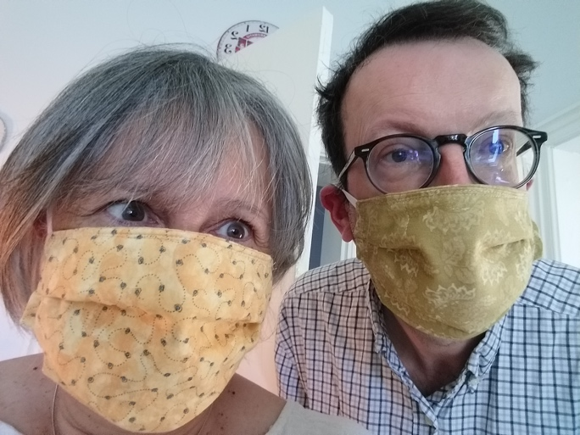
Along the canal on a daily walk:
The buttercups look beautiful.
Do you like butter??
If they shine under your chin....
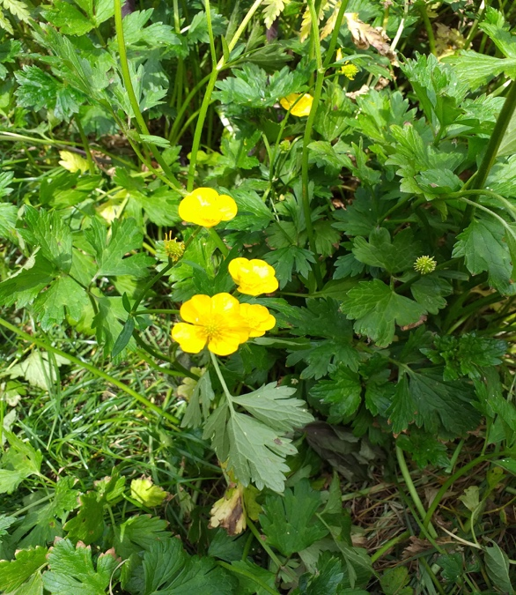
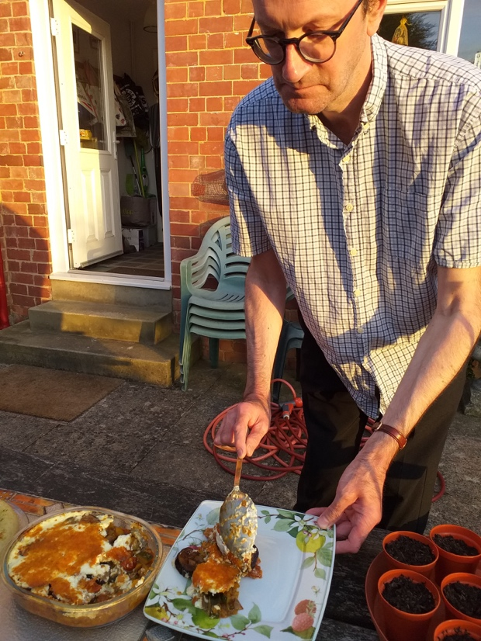
Lily’s Moussaka alfresco style.
Absolutely delicious!
Thanks again Lily.

Steve, Laura and Jenson (and dog Rocky) in a park near them on their ‘non-wedding day’ (23rd May). Thank you everyone for your prayers and best wishes. “It’s still all to look forward to!” they (and we) say.

