Tolly Theology

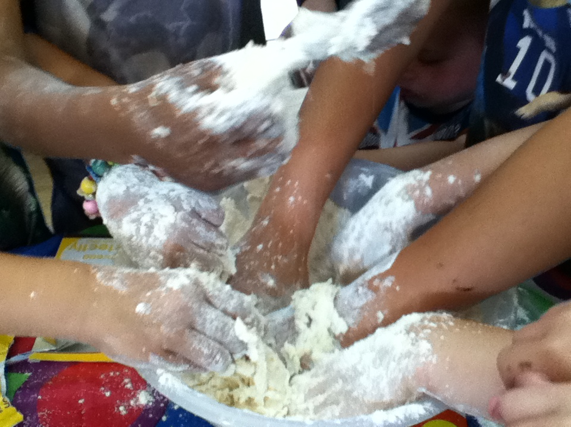

When we were first invaded by the kids of Tolladine, we hoped that they would share with us their insights into what the Gospel would come to mean for them.

Here are a few of the ideas that rocked us.

Good Shepherd Sunday
We were working with the story of Jesus as the good shepherd who lays down his life for his sheep (John 10). We had built a sheepfold on the floor before the altar with Jesus at the gate and most of us were busy making model sheep representing ourselves.
But one of the children had a different thought. She had brought with her a Barbie doll dressed in nothing but fishnet tights. Now she took a sheet of white tissue and fashioned a wedding dress which she wrapped around the doll. Then she cut out a baby in swaddling clothes and place the bundle in one arm of her bride. She cut out a cross and placed that in the other arm; and then she placed her Bride of Christ with child with her cross alongside Jesus at the sheep-fold gate.
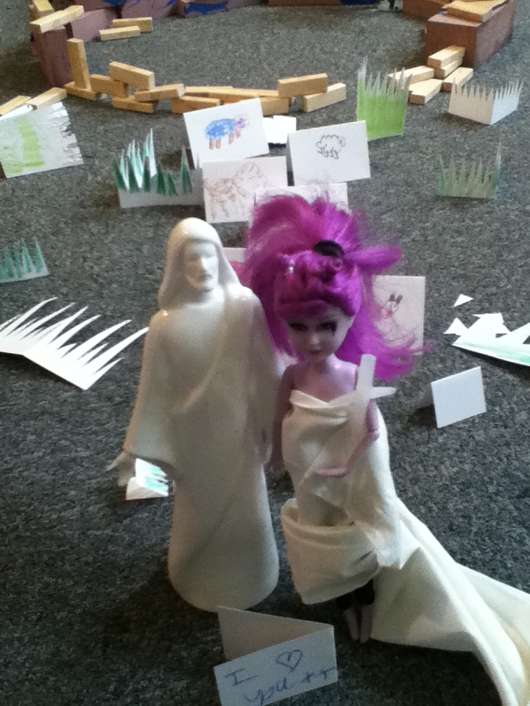

Good Friday
We were processing from the church carrying a simple wooden cross in with the intention of erecting it on a patch of waste land alongside Rose Avenue.
The cross was being carried by a particularly troubled boy, who had given us, the ‘grown ups’, a lot of concern, but he had had been adamant in wanting to carry the cross.
As we were walking down the road, a lorry pulled up opposite and the driver leaned out and asked
“What is the way to Holymount?”
Quite as a flash our cross-carrier replied,
“Jesus is the way, mate!”

Passion Sunday
We were exploring prayer and what could be achieved through praying to Jesus.
Each of us made a paper plate with a prayer on it. But one child, perhaps thinking of the events that were to come, changed the idea and wrote this: -
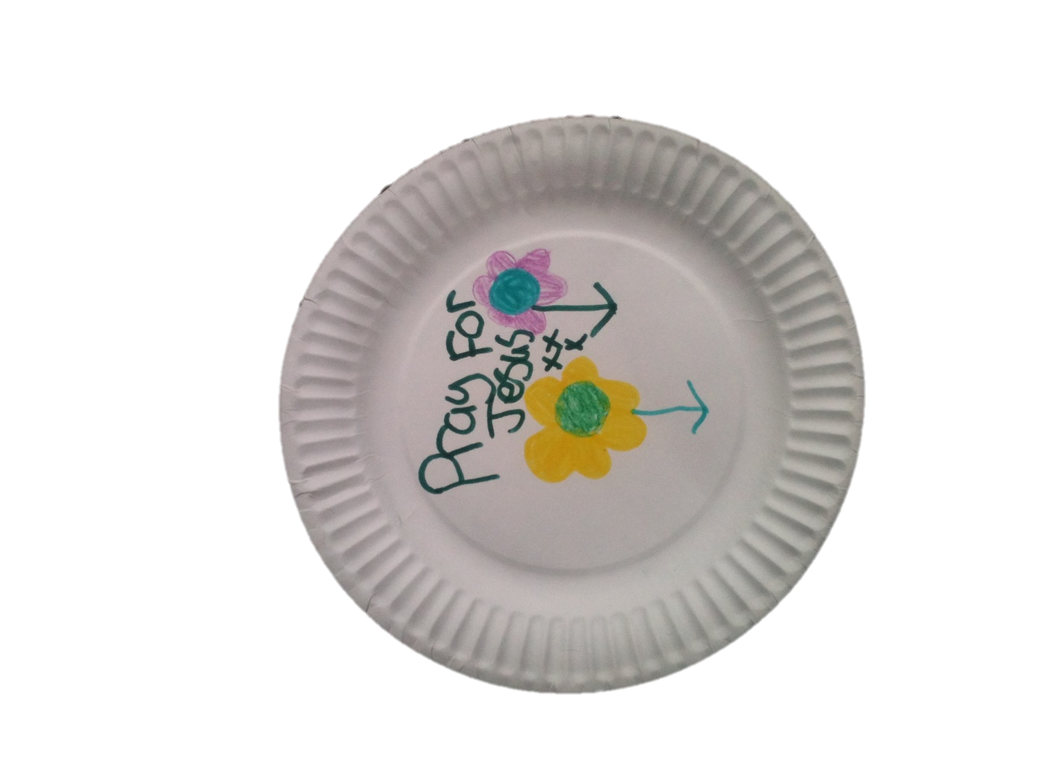

Easter Sunday

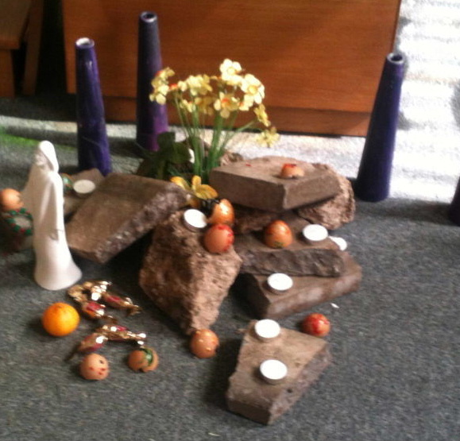

We were sitting around the Easter Garden and looking at the empty tomb.
“Would you have been scared if you had come across an empty tomb?” asked one of the adults.
“No” replied a child, “because it would be new life!”

Another Sunday

On Good Friday, a door had slammed and the cross with Jesus on it has fallen from the wall behind the altar. As it fell, Jesus became detached. His body, with arms raised, looked as if he were flying. This was an awesome happening, stimulating a lot of thought and conversation about the meaning of Easter.
The detached body of Jesus was cared for during the following weeks. When some juice from an Agape communion was accidentally spilled on it, the girls lovingly wiped it off.
Eventually some-one said “We had better fix Jesus back on the cross. I’ll get some glue.”
“No!”, said a child, “I never want to put Jesus back on the cross.”

